**.reduce( ) it takes all of the elements in an array and reduces them into a single value**

**By default .reduce() executes from left to right**

**And we have reduceRight() that executes from right to left**

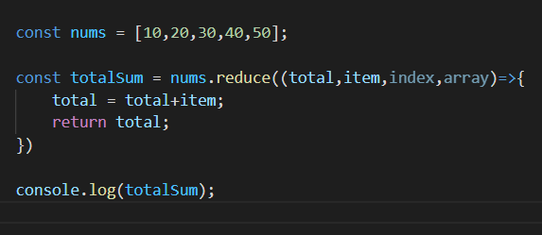

Above total === array[0];

Basically that first argument to callback function ( total ) inside.reduce() method, is where we reduce the entire array

And in reduceRight() that argument “total” becomes the last item of array or first-item from the right